Episode 510: Properties of radiations

The focus of this episode is the properties of ionizing radiation. It is a good idea to introduce these through a consideration of safety.
Lesson Summary
- Discussion: Ionising radiation and health (10 minutes)
- Demonstration: Deflection of beta radiation (10 minutes)
- Student activity: Completing a summary table (10 minutes)
- Student experiment: Inverse square law for gamma radiation (30 minutes)
- Discussion: Safety revisited (5 minutes)

Discussion: Ionising radiation and health
Why are radioactive substances hazardous? It is the ionising property of the radiation that makes it dangerous to living things. Creating ions can stimulate unwanted chemical reactions. If the radiation transfers sufficient energy it can split molecules. Disrupting the function of cells may give rise to cancer. Absorption of radiation exposes us to the risk of developing cancer.
Thus it is prudent to avoid all unnecessary exposure to ionising radiation. All deliberate exposure must have a benefit that outweighs the risk.
Radioactive contamination is when you get a radioactive substance on, or inside, your body (by swallowing it or breathing it in or via a flesh wound). The contaminating material then irradiates you.
How can you handle sources safely in the lab? Point out that you will be safe if you follow your local rules which will incorporate the following:

- Always handle sources with tongs
- Point the sources away from your body (and not at any anybody else)
- Fix the source in a holder which is not adjacent to where your body will be when you take measurements
- Replace sources in lead-lined containers as soon as possible
- Wash hands when finished

Radioactive sources
Follow the local rules for using radioactive sources, in particular do not handle radioactive sources without a tool or place them in close proximity to your body.

Demonstration: Deflection of beta radiation
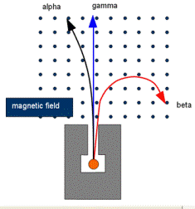
Show the deflection of β by a magnetic field. (Make sure you have a small compass to determine which are the N and S poles of the magnet.) Is the deflection consistent with the LH rule? (Yes; need to recall that electron flow is the opposite of conventional current.) This demonstration is no good with the α particles, as they are absorbed too quickly by the air.)
NB The diagram above is common in textbooks, but is only illustrative. For the curvature shown of beta particles, the curvature of the alpha tracks would be immeasurably small.

Student activity: Completing a summary table
Display the table, with only the headings and first column completed. Ask for contributions, or set as a task; compile results.
Episode 510-1: α, β and γ radiation (Word, 39 KB) - see end of document

name | symbol | nature | electric charge | stopped by | ionising power | What is it?
Alpha | α | particle | +2 | mm air; paper | very good | He nucleus
Beta | β | particle | -1 | mm Al | medium | very fast electron
Gamma | γ | wave | 0 | cm Pb* | relatively poor | electromagnetic radiation
Can you see any patterns in the table? (Most ionising – the largest electrical charge – is the least penetrating.) Can you explain this? (The most ionising transfer energy the quickest.) How can the electrical charge determined? Deflection in a magnetic field.)
*NB Gamma radiation is never completely absorbed (unlike alpha and beta) it just gets weaker and weaker until it cannot be distinguished form the background.

Student experiment: Inverse square law for gamma radiation
Note: since you are unlikely to have sufficient gamma sources for several groups to work simultaneously, this experiment can be part of a circus with others in the next episode. Alternatively, it could be a demonstration.
Gamma radiation obeys an inverse square law in air since absorption is negligible. (Radiation spreads out over an increasing sphere. Area of a sphere = 4 π r ² , so as r gets larger, intensity will decrease as 1/ r ² . The effect of absorption by the air will be relatively small.
Episode 510-2: Range of gamma radiation (Word, 38 KB) - see end of document

(Some students could do an analogue experiment with light, with an LDR or solar cell as a detector.)
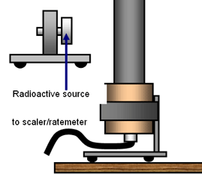
When detecting g radiation with a Geiger tube you may like to aim the source into the side of the tube rather than the window at the end. The metal wall gives rise to greater secondary electron emission than the window and this increase the detection efficiency.
Correct readings for background.
How can we get a straight line graph? We expect
I ∝ r ⁻²,
so a plot of I versus r ^{–2} should be direct proportion (i.e. a straight line through the origin). It is much easier to see if a graph is a straight line, rather than a particular curve. Lift the graph and look along the line – it’s easy to spot a trend away from linear. However, two points are worth noting:
- Sealed γ sources do not radiate in all directions, so do not expect perfect 1r ² behaviour
- You do not know exactly where in the Geiger tube the detection is taking place, so plotting I ^{- ½} against r gives an intercept, the systematic error in the measurement.

Discussion: Safety revisited
Return briefly to the subject of safe working. Background radiation is, say, 30 counts per minute. How far from a gamma source do you have to be for the radiation level to be twice this? Would this be a safe working distance? (Probably.) How much has your lifetime dose of radiation been increased by an experiment like the above? (Perhaps one hour at double the background radiation level – a tiny increase. It will be safe enough to carry out a few more experiments.)
Episode 510-1: α, β and γ radiation

Using your knowledge from pre-16 level work, or using information from textbooks, draw up a table to summarise the properties of α, β and γ radiation.

The table below provides a framework for your summary. Write items from the following list into appropriate cells of the table. Note that some of the items are not needed and some may be used more than once.

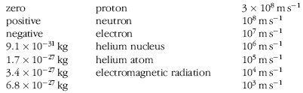

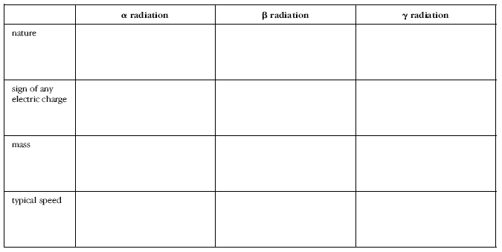

Practical Advice
Some text books may be needed.

External reference
This activity is taken from Salters Horners Advanced Physics, section DIG, activity 25

Episode 510-2: Range of gamma radiation

Penetrating electromagnetic radiation
Gamma radiation is emitted by a nucleus in order to drop from an excited state to a more stable one. Gamma rays are high-frequency members of the electromagnetic spectrum. In this activity you will assess the penetrating power of gamma rays and also the way in which their intensity changes with distance.

You will need
- gamma source and holder
- set of absorbers: various thicknesses of lead
- a Geiger–Müller tube and associated power supply
- suitable means for mounting the GM tube a fixed measurable distance from the source
- forceps or tweezers for handling the radioactive source
- stop clock
- metre rule
- micrometer screw gauge or vernier calliper for making thickness measurements
- set square

Radioactive sources
Follow the local rules for using radioactive sources, in particular do not handle radioactive sources without a tool or place them in close proximity to your body.

Making measurements
1. Set up the GM tube and counter to take a background reading. This background value will need to be subtracted from each subsequent reading you take when using the gamma source.
2. Fix the gamma source 10–15 cm from the front window of the GM tube (do not remove any plastic cap that is protecting it). The separation of the source and counter and the orientation of the source must be fixed – not too hard to see why so take care. (Because we are investigating absorption, we want a fixed geometry so that the results are not confused by the inverse square law effect investigated later.)
3. Take a reading of the number of gamma photons over a sensible time period and convert this to a rate of arrival per second.
4. Insert one of your lead sheets between the tube and source close to the GM tube, finding the new count rate for each absorber thickness. Be sensible – a short preliminary experiment using a very thin absorber and a very thick one in order to get a feeling for the range of count rates that you will encounter will save you time later. You can also plot as you go (count rate against thickness of lead), looking for patterns and anomalies.

Analysis
5. Try to find the thickness of lead for which half the incident gamma radiation is absorbed. Is the pattern exponential? Can you check?

Comparisons with beta particles
(To be done if your class has carried out the activity dealing with the range of beta particles. TAP episode 511-2)
6. Do the gamma rays penetrate further into the lead than beta particles? Which are the better ionisers?
7. Plot a graph of corrected count rate against thickness. Draw a smooth curve through the points.
8. If you have carried out the 'more sophisticated analysis' for beta particles you might like to repeat the logarithmic plot here too.

The inverse square law – a fresh start
Theory predicts that electromagnetic radiation should vary with distance according to an inverse square rule. With a little care, you can test this.
1. Remove the lead sheets – they are not needed again – and move the gamma source closer to the tube. This starting distance must not be so close that your GM tube is overwhelmed by counts and misses some out. Some trial and error may be needed.
2. Measure the distance from the thin window of the GM tube to the front of the source. A possible way to do this is to use a set square to transfer the measurement to a metre rule taped to the bench.
3. Obtain the average count rate for this distance.
4. Repeat the experiment over a wide range of distances, taking care with the alignment of the sources.
5. Does the inverse square law describe your results?

A more careful analysis
You measured a distance from the window of the GM tube to the front of the source. This leads to two problems: the source itself is on a foil and lies a few millimetres behind the wire mesh of its holder and the average detection point is somewhere inside the GM tube.
Theory predicts that the intensity of the gamma rays varies with the inverse square of the distance:

$$y∝\frac{1}{x^{2}}$$
which can be rewritten as
$$y=\frac{k}{x^{2}}$$
However, the two problems mean that the true value of x is unknown and that it should be written as x + c where c is a correction that converts your (inaccurate) measurement of distance x into the correct value.
So the equation becomes
$$y=\frac{1}{{\left(x+c\right)}^{2}}$$
and a plot of y against x2 will not be a straight line.
The trick is to take square roots of both sides:
$$y^{12}=\frac{1}{\left(x+c\right)}$$
leading to
$$\frac{1}{y^{12}}=x+c$$
So if the gamma rays obey an inverse square law, a plot of 1 / y1/2 against x ought to be a straight line. The intercept on the x-axis will give you an estimate of c, the error in the distance determination.
Plot your data in this way and decide if they verify the inverse square law.

You have seen that
1. Gamma radiation is very penetrating. It will go through metres of lead and concrete. Gammas are poor ionisers. Half thicknesses can be measured, to characterise absorbers.
2. Gamma rays, like all electromagnetic radiation, obey the inverse square law. Double your distance from the source and you reduce the intensity by four times.

Practical advice
Students will need to take care with the measurements, particularly with alignments. You may choose to make up apparatus to allow this to be easily controlled. The more careful analysis is only for mathematically competent students. It can be omitted without loss.

Be safe
Follow local rules for using radioactive sources.

Social and human context
Nuclear reactors and other nuclear machines are surrounded by huge amounts of concrete or lead to prevent the radiation emitted during the reactions causing a hazard to us. (When would you choose concrete and when lead? When there is room for lots of concrete, it is used because it is much cheaper than lead.)

External reference
This activity is taken from Advancing Physics chapter 18, 110E

